Laxmi Charitable Trust’s
Sheth L.U.J College of Arts & Sir M.V. College of Science and Commerce
Department of Information Technology (B.Sc.I.T Semester V)
Data Visualization with Power BI and Tableau
Practical – I
Roll No :- 53 | Name :- Nidhi Yadav
Class :- TYIT | Batch :- 2
Date of Assignment :- 24/07/2024 | Date/Time of Submission :- 24/07/2026
Part C – Curiosity Question
Curiosity Question
question:
Using a dataset of your choice (CSV format), create an interactive Tableau dashboard that effectively presents key insights from the data.
Requirements:
- Import your own dataset into Tableau.
- Identify appropriate Dimensions and Measures.
- Create at least three different visualizations (e.g., bar chart, line chart, map, pie chart, scatter plot, etc.).
- Add at least one filter or interactive element to the dashboard.
- Arrange the charts into a single interactive dashboard with a clear title.
- Write 3–5 observations explaining the insights gained from your dashboard.
Submission:
- Tableau Workbook (.twb or .twbx)
- Dataset (.csv)
- Screenshot of the completed dashboard
A short report containing the observations
Getting Started with Tableau and Building Basic Visualizations
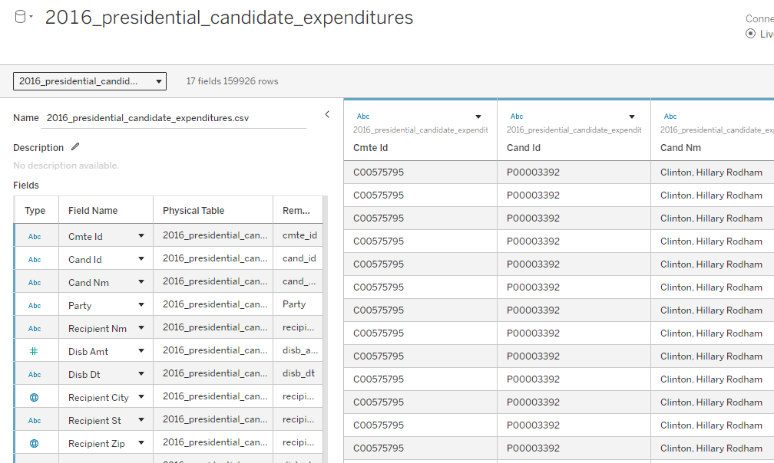
- Connect to a CSV dataset and explore the Tableau interface
b)Identify and differentiate Measures and Dimensions
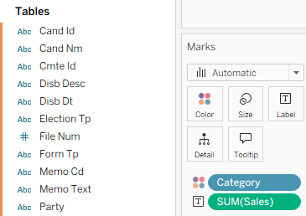

- Convert fields between discrete and continuous and observe changes
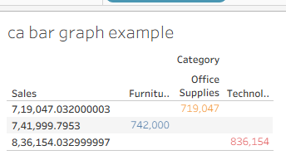
d) Create and customize a basic bar chart
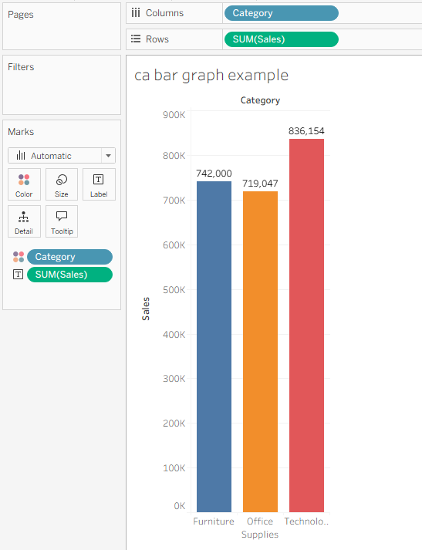
e) Build a line chart for time-series analysis
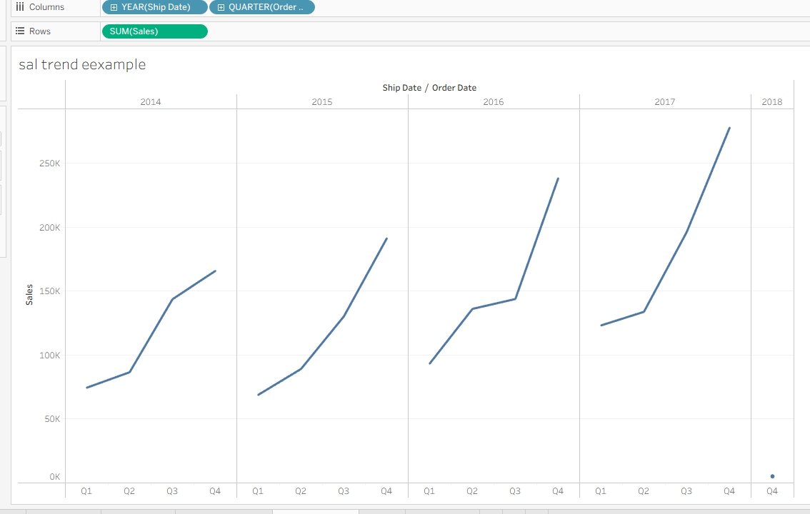
f) Create a geographic map visualization
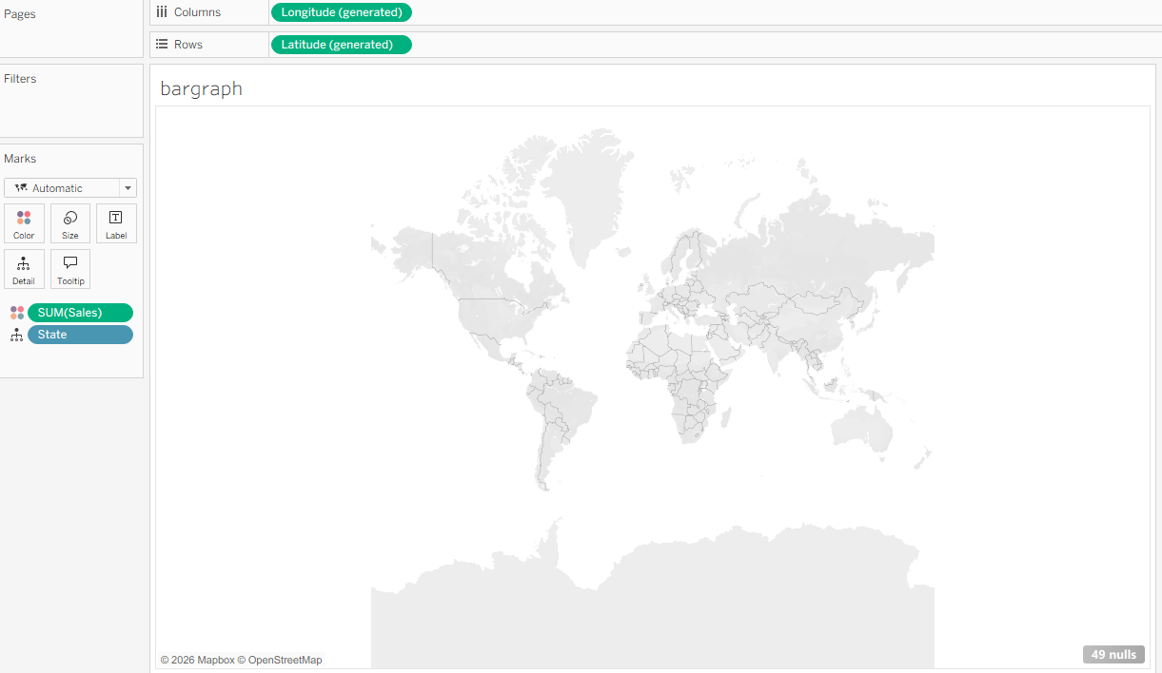
g) Combine multiple charts into a simple interactive dashboard
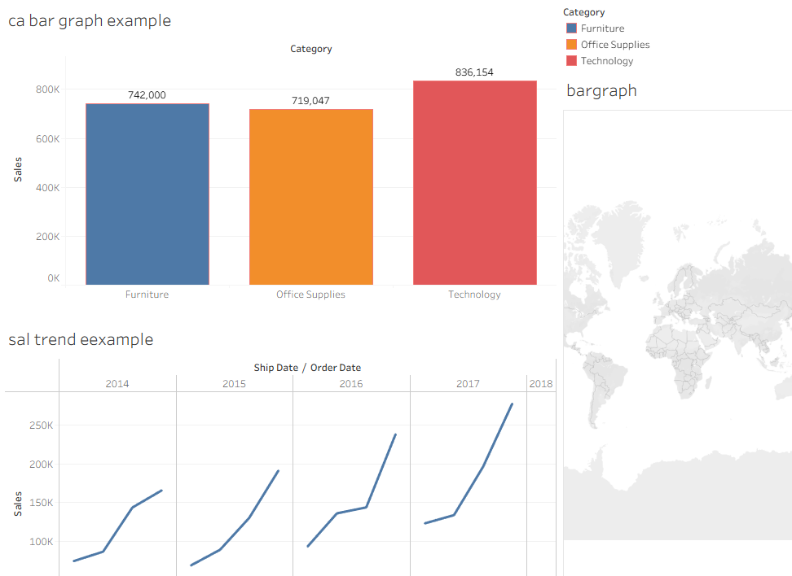
1 The Technology category has the highest sales, while Office Supplies has the lowest sales.
The Furniture category also has good sales, but they are slightly lower than the Technology category.
3 The sales keep increasing from 2014 to 2018, which shows that the business is growing steadily.
4 The highest sales were recorded in 2018, making it the best-performing year in the dashboard.
5 Using the bar chart, line chart, and map in one dashboard makes the data easier to understand and compare.

.

